NEKAAA
General Public
Transportation
Passenger
Handbook
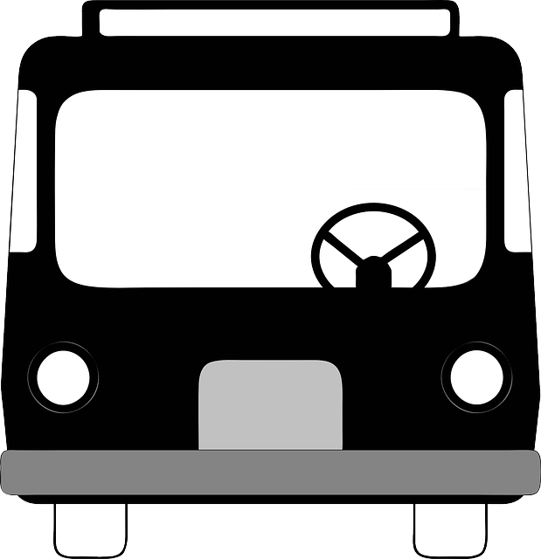

To schedule a ride, call:
NEKAAA GENERAL PUBLIC TRANSPORTATION
(785)742-7153

Funded by KDOT Public Transportation & NEKAAA

Who can ride the van?:
We are a DEMAND RESPONSE, “First come, first served” origin to destination service, to EVERYONE. All children age six and under must be accompanied by an adult. Children up to 17 years old must have PARENT contact the NEKAAA General Public Transportation.

Service Animals/Pets:
Only service animals will be permitted to ride. All other animals have to be in a crate and secured like cargo.

Area of Service:
Services are available throughout Brown County. Limited service is available outside of Brown County.

Fares:
NEKAAA General Public Transportation operates a fee-for-service system. Fares have to be paid when you board the van with exact amount. The driver doesn’t carry change. Passengers who do not pay the required fare for their ride will be denied service. One personal care attendant will be permitted to ride without charge.
We offer pre-paid punchcard at variety prices.

Scheduling/Making changes:
Reservations are taken Monday through Friday from 8:00 am to 4:30 pm by calling 785-742-7153. Appointment rides start Monday through Friday at 7:00 am to 4:00 pm. After hours, ride cancellations may be left on the answering machine. To assure a ride, it is advised to book your ride as far ahead as possible. We can schedule rides for you, up to six months in advance. Passengers need to indicate ALL STOPS
(due to scheduling, we can’t make any extra stops) when making their reservation. Same day rides can be scheduled if time allows. Drivers are not responsible for the scheduling of
trips. All scheduling and messages is handled through calling NEKAAA General Public Transportation .

Holiday:
We observe these holidays on which no service available: New Year’s Day; Martin Luther King, Jr. Day; President’s Day; Good Friday; Memorial Day; Independence Day; Labor Day; Veteran’s Day; Thanksgiving (Thursday and Friday); and Christmas Day.

Bad Weather Policy:
If Hiawatha USD 415 closes prior to 8:00 a.m. due to snow or ice, NEKAAA General Public Transportation service will also be closed. Radio stations KMZA-FM 92.1 and KNZA-FM 103.9 will have weather related announcements regarding our transportation services during times of bad weather. If management and drivers agree the weather is to severe to operate, then operations will cease for the day.

Pickup times/wait policy:
Passengers need to be ready for pickup 10 minutes prior to the scheduled pick up time. The driver will wait ten (10) minutes for a passenger after the scheduled pickup time. Upon arrival, the driver will honk the horn. If passenger does not respond to the driver honking the horn, after 5 minutes with no response, driver will call passenger. If the driver cannot make contact with passenger within ten (10) minutes the driver will leave. Passenger will be considered a no-show for that ride and any remaining rides passenger has for the rest of that day will automatically be cancelled.

Delays:
Due to the number of rides we provide, it is not always possible for vehicles to run exactly on schedule. Driver has up to 10 minutes past scheduled time to pickup passenger. It is important for passengers to allow extra time to assure scheduling needs can be met.

Cancellation policy:
Cancellations an hour or less prior to the scheduled ride time will be treated as no-shows.

Passenger Safety/Seat Belts:
Wearing seat belts is the law, all passengers are expected to stay seated in the vehicle with the seat belt on until the vehicle comes to a complete stop and wearing them properly is required. Children under four years old must be in a child safety seat, while children 4-8 years old and under 80 pounds must be in a safety or booster seat, provided by the passenger.

Personal Assistance to Passengers:
Drivers are allowed to offer only limited personal assistance to passengers. Drivers are permitted to assist passengers with activities directly related to boarding or departing the vehicle safely. Drivers will assist passengers who have assistive mobility or medical devices (walkers, canes, oxygen tanks, etc.) with securing devices in the van. Passengers that have difficulty using steps can request to use the ramp. Drivers are not permitted to lift passengers wanting to transfer from a scooter or mobility device to regular vehicle seating. Such passengers must provide their own personal care attendant to assist in their transfer. One personal attendant will be permitted to ride without charge. Passenger needs to have one personal care attendant when help is needed from home to van/van to destination. Passengers may not expect NEKAAA General Public Transportation to transport oversize or heavy items. Bicycles are permitted with 24 hr notice and if it fits in van. We would need measurements when scheduling.

Mobility Device Procedures:
The driver is responsible to see that all passengers with disabilities are properly locked in mobility device locks and restraint system belts before moving the vehicle. Passengers with disabilities are also required to wear seat belts and shoulder straps.

Conduct and hygiene:
Inappropriate conduct, including behaviors which present a danger to other passengers will not be tolerated. These include, but are not limited to: fighting; arguing; threatening of anyone on the vehicle; use of foul language and sexual harassment. Any passengers’ behavior that poses a safety hazard to him/herself or others caused by misplaced bodily fluids, disregard for cleanliness, being under the influence of drugs or alcohol, or anything deemed a public health hazard will be denied transportation. There are consciouses for such actions. Drivers, with approval from the dispatcher, may put a passenger off the vehicle or call authorities if necessary.

No-Shows:
A no-show is when a passenger books a ride, then fails to take or cancel the ride as scheduled in a timely manner. NEKAAA General Public Transportation sets the following policy regarding no-shows: three no-shows in a 90 day period shall be suspended from ridership for 30 days. A letter of warning will be sent after each no-show. A passenger may appeal a suspension through the grievance procedure process. Rides will continue during the appeals process. Special consideration will be given for no-show situations during inclement weather or for medical emergencies.

No food, drink or tobacco products may be consumed on the van.

Bottled water is permitted only.

Grievance Procedure:
This grievance procedure has been developed to assure passengers of fair and equitable access to the NEKAAA system. When a passenger has any problem, the following procedure should be followed to resolve the conflict. Each passenger is expected to communicate directly to the dispatcher regarding ride-related actions, occurrences or attitudes perceived as unfair and inequitable. A passenger who believes he/she has suffered a grievance should discuss the matter with the dispatcher within five working days of the occurrence of the alleged grievance, in an attempt to arrive at a satisfactory solution.
The dispatcher will have five working days to respond, making every effort to resolve the grievance at this level.

If a resolution is not reached, the grievance must be described in writing and submitted to the Director of NEKAAA. The NEKAAA Director will review the evidence presented by the party bringing the grievance to the board within thirty working days and will provide a decision in writing to all parties involved. The Board of NEKAAA decision is final.

If the above described steps fail to resolve the grievance, the customer may file administrative or legal action available according to local, state or federal law.

Information you need to provide for your ride:

- Name: _______________________________________________

- Your address: _________________________________________

- Your phone number: ____________________________________

- Date for your ride: ______________________________________

- Cane, Walker or Mobility Device:___________________________

- Destination name & address: ______________________________
_____________________________________________________

- Will you require a return ride? Yes No

- Possible appt/wait time: __________________________________

- Destination address for return ride: _________________________

- Name of additional passenger (should you have them):
_____________________________________________________

- Specific Instructions regarding pick up location if needed:
_____________________________________________________

- Any additional information you would like transportation to know:
_____________________________________________________

NOTIFYING THE PUBLIC OF RIGHTS UNDER TITLE VI

NORTHEAST KANSAS AREA AGENCY ON AGING, INC.

*Northeast Kansas Area Agency on Aging, Inc. (NEKAAA) operates its programs and services without regard to race, color and national origin in accordance with Title VI of the Civil Rights Act. Any person who believes he or she has been aggrieved by any unlawful discriminatory practice under Title VI may file a complaint with NEKAAA.

*For more information on NEKAAA’s civil rights program and the procedures to file a complaint, contact 1-800-883-2549, email nekaaa@nekaaa.org or visit our administrative office at 1803 Oregon Street, Hiawatha KS 66434.

*A complainant may file a complaint directly with the Federal Transit Administration by filing a complaint with the Office of Civil Rights,
Attention: Title VI Program Coordinator, East Building, 5th Floor-TCR,
1200 New Jersey Avenue, SE, Washington, DC 20590.

